**– Tables and Stored Procedures created**

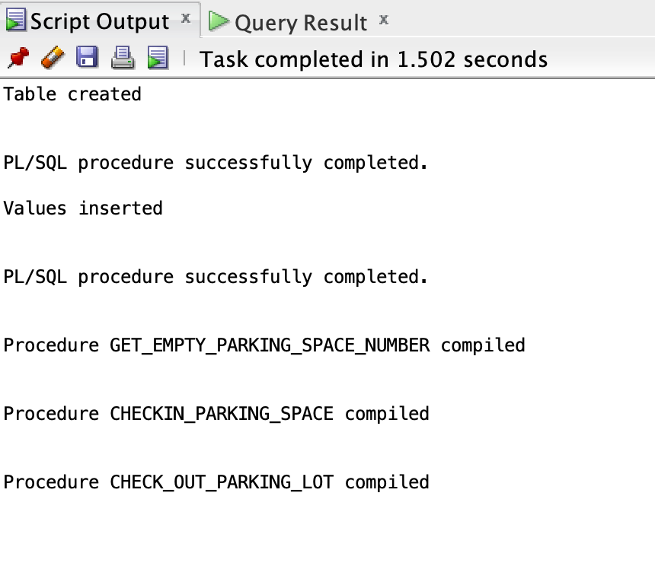

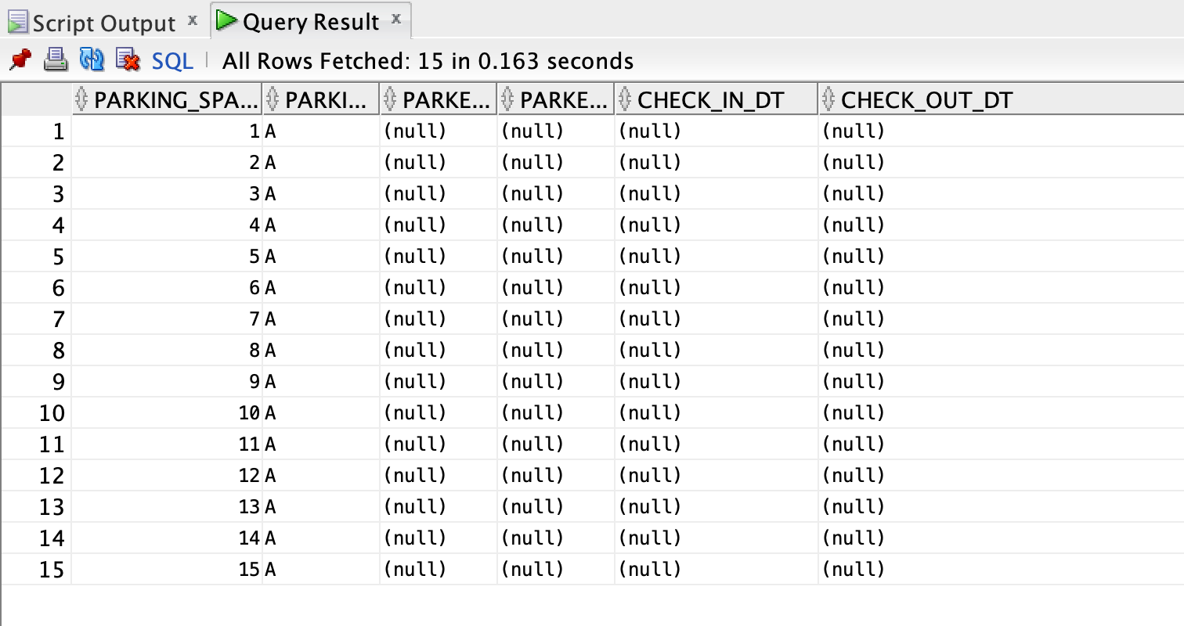

-- check available spots

exec get_empty_parking_space_number();

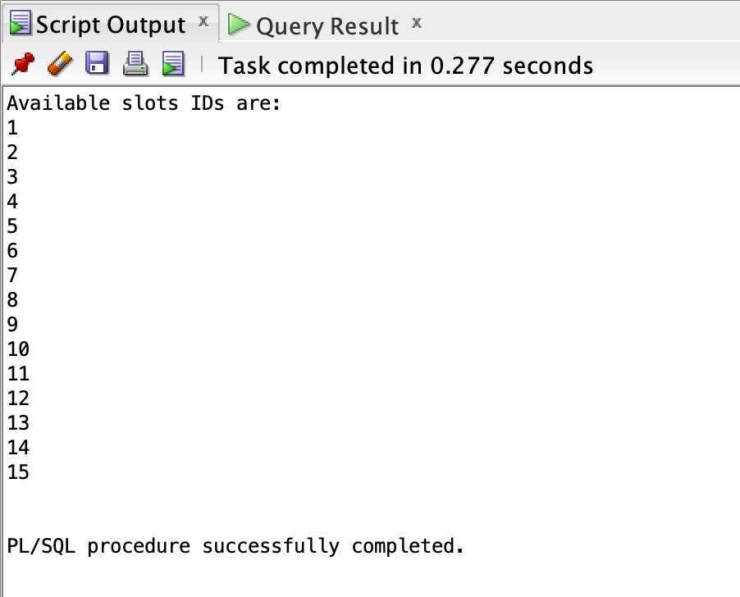

**– TEST CASES:**

---- 1) Insert given data

--A) Checkin_Parking_Space: RED, UBX987, 1-JAN-2022, 14

declare

x varchar(20);

begin

x := 14;

Checkin_Parking_Space('RED', 'UBX987', '1-JAN-2022', x);

if x = 200 then

dbms_output.put_line('Sorry, try again!');

else

dbms_output.put_line('Checked into parking space number '|| x);

end if;

end;

/

--B) Checkin_Parking_Space: WHITE, ZZX954, 1-JAN-2022, NULL

declare

x varchar(20);

begin

x := null;

Checkin_Parking_Space('WHITE', 'ZZX954', '1-JAN-2022', x);

if x = 200 then

dbms_output.put_line('Sorry, try again!');

else

dbms_output.put_line('Checked into parking space number '|| x);

end if;

end;

/

--C) Checkin_Parking_Space: YELLOW, UEX982, 1-JAN-2022, NULL

declare

x varchar(20);

begin

x := null;

Checkin_Parking_Space('YELLOW', 'UEX982', '1-JAN-2022', x);

if x = 200 then

dbms_output.put_line('Sorry, try again!');

else

dbms_output.put_line('Checked into parking space number '|| x);

end if;

end;

/

--D) Checkin_Parking_Space: BLUE, AAX983, 2-JAN-2022, NULL

declare

x varchar(20);

begin

x := null;

Checkin_Parking_Space('BLUE', 'AAX983', '2-JAN-2022', x);

if x = 200 then

dbms_output.put_line('Sorry, try again!');

else

dbms_output.put_line('Checked into parking space number '|| x);

end if;

end;

/

--E) Checkin_Parking_Space: RED, BBX987, 3-JAN-2022, NULL

declare

x varchar(20);

begin

x := null;

Checkin_Parking_Space('RED', 'BBX987', '3-JAN-2022', x);

if x = 200 then

dbms_output.put_line('Sorry, try again!');

else

dbms_output.put_line('Checked into parking space number '|| x);

end if;

end;

/

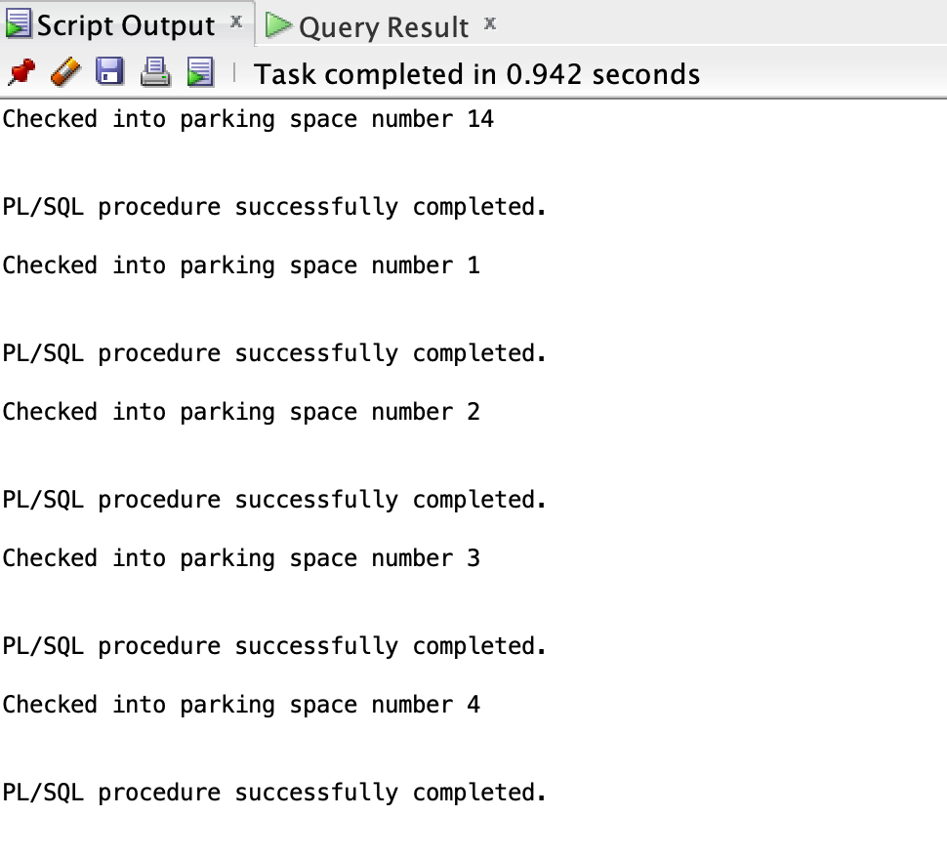

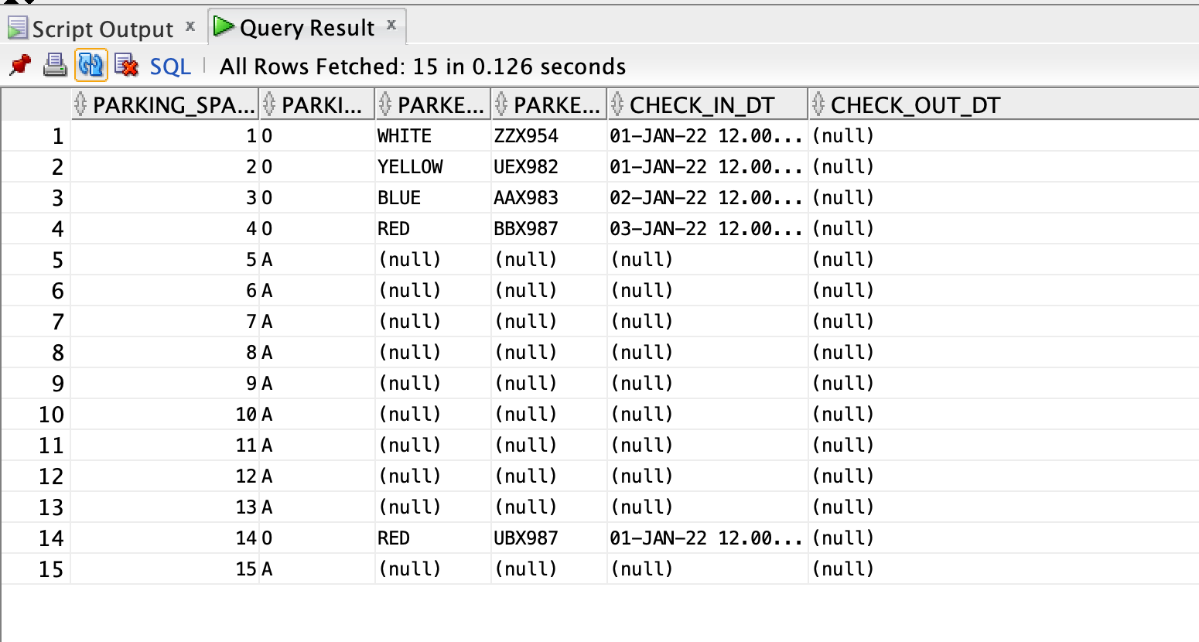

--F) Checkin_Parking_Space: RED, CCX585, 4-JAN-2022, 14 (Should throw error as already occupied)

declare

x varchar(20);

begin

x := 14;

Checkin_Parking_Space('RED', 'CCX585', '4-JAN-2022', x);

if x = 200 then

dbms_output.put_line('Sorry, try again!');

else

dbms_output.put_line('Checked into parking space number '|| x);

end if;

end;

/

--G) Checkin_Parking_Space: WHITE, CCX585, 4-JAN-2022, 13

declare

x varchar(20);

begin

x := 13;

Checkin_Parking_Space('WHITE', 'CCX585', '4-JAN-2022', x);

if x = 200 then

dbms_output.put_line('Sorry, try again!');

else

dbms_output.put_line('Checked into parking space number '|| x);

end if;

end;

/

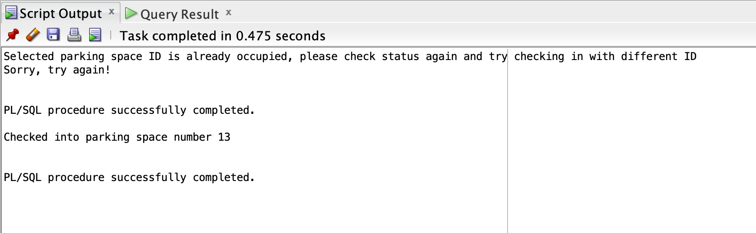

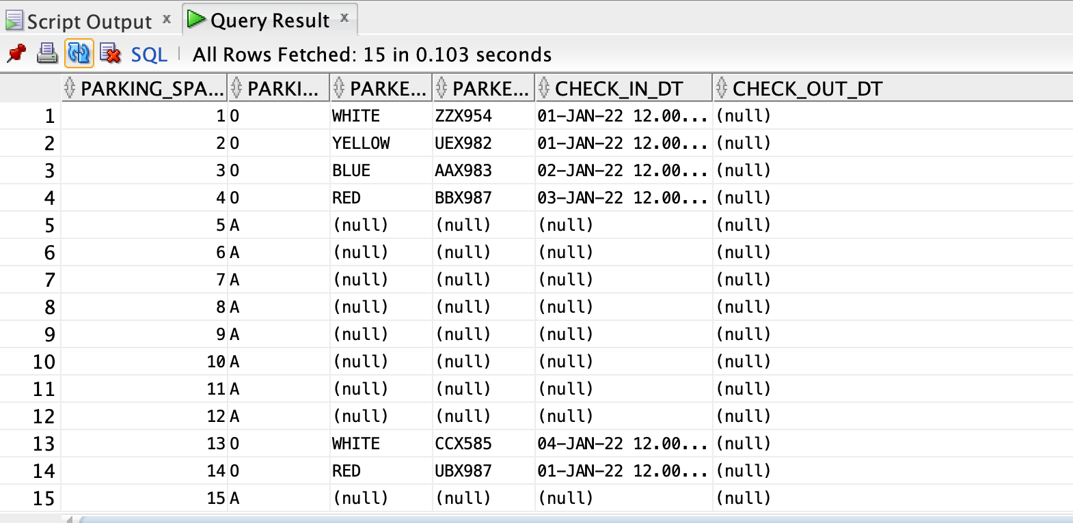

--H) Checkin_Parking_Space: YELLOW, CCX585, 4-JAN-2022, 15

declare

x varchar(20);

begin

x := 15;

Checkin_Parking_Space('YELLOW', 'CCX585', '4-JAN-2022', x);

if x = 200 then

dbms_output.put_line('Sorry, try again!');

else

dbms_output.put_line('Checked into parking space number '|| x);

end if;

end;

/

--I) Checkin_Parking_Space: BLUE, CCX585, 4-JAN-2022, 11

declare

x varchar(20);

begin

x := 11;

Checkin_Parking_Space('BLUE', 'CCX585', '4-JAN-2022', x);

if x = 200 then

dbms_output.put_line('Sorry, try again!');

else

dbms_output.put_line('Checked into parking space number '|| x);

end if;

end;

/

--J) Checkin_Parking_Space: WHITE, CCX585, 4-JAN-2022, 12

declare

x varchar(20);

begin

x := 12;

Checkin_Parking_Space('WHITE', 'CCX585', '4-JAN-2022', x);

if x = 200 then

dbms_output.put_line('Sorry, try again!');

else

dbms_output.put_line('Checked into parking space number '|| x);

end if;

end;

/

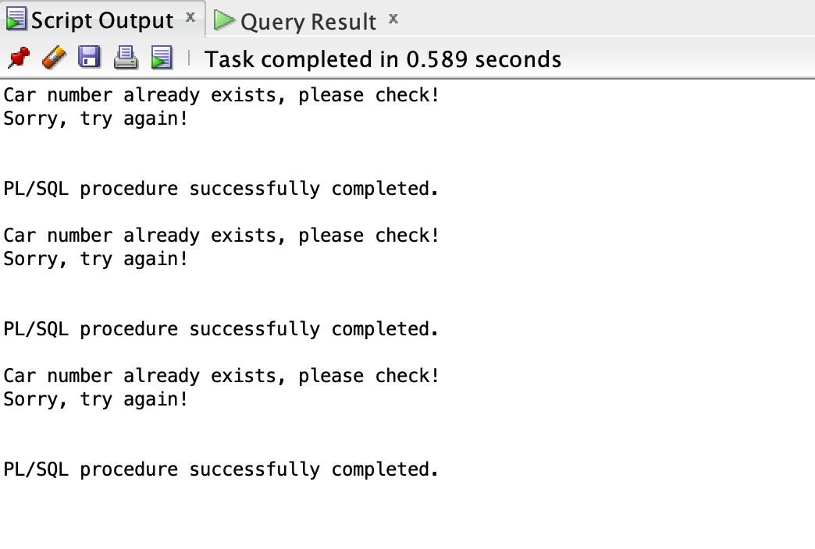

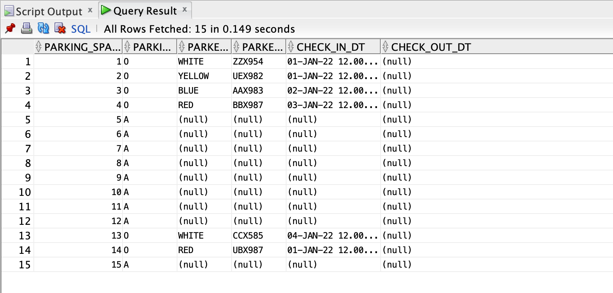

-- check available spots

exec get_empty_parking_space_number();

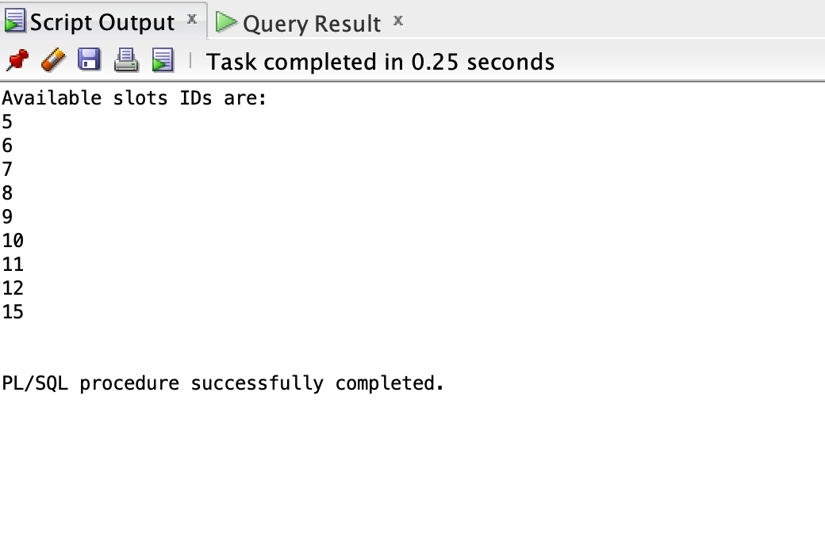

**-- Test cases for check out**

select * from nyc_parking_lot where parked_car_color = 'WHITE';

exec Check_Out_Parking_Lot('ZZX954', '');

exec Check_Out_Parking_Lot('CCX585', '');

select * from nyc_parking_lot where parked_car_color = 'WHITE';

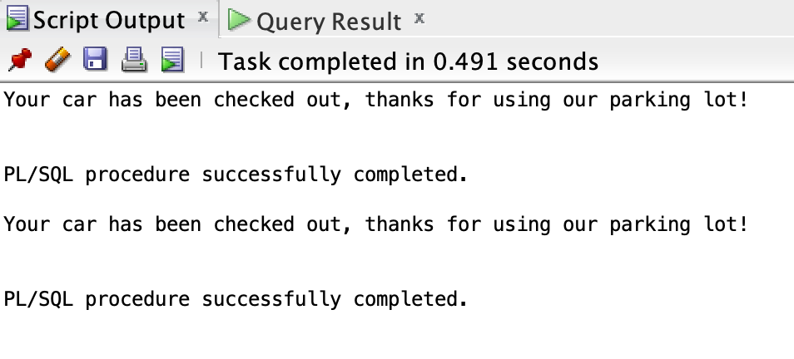

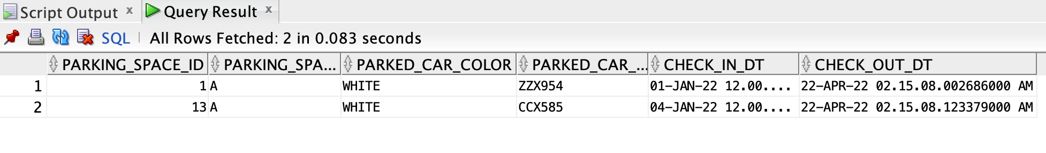

**-- Entire Code**

set serveroutput on;

--drop table NYC_Parking_Lot;

-- Create table if exists

begin

execute immediate (

'create table NYC_Parking_Lot(

parking_space_id number primary key,

parking_space_status varchar(20) default ''A'',

parked_car_color varchar(50),

parked_car_reg_number varchar(50) constraint nyc_car_uk unique,

check_in_dt timestamp,

check_out_dt timestamp)');

dbms_output.put_line('Table created');

exception

when others then

if sqlcode = -955 then

dbms_output.put_line('Table already exists');

else

raise;

end if;

end;

/

-- Insert values for parking space ID

declare

v_cnt number;

begin

select count(*) into v_cnt from NYC_Parking_Lot;

if v_cnt = 0 then

for i in 1..15 loop

insert into NYC_Parking_Lot(parking_space_id) values(i);

end loop;

commit;

dbms_output.put_line('Values inserted');

else

dbms_output.put_line('Cannot insert values, clear table and insert again. (Count Exceeded 15');

end if;

end;

/

-- create store procedure to display empty parking lots

create or replace procedure get_empty_parking_space_number

is

v_checkCount number;

v_parkingId nyc_parking_lot.parking_space_id%TYPE;

v_parking_space_status nyc_parking_lot.parking_space_status%TYPE;

cursor c_checkLot is select parking_space_id, parking_space_status from NYC_Parking_Lot;

begin

v_checkCount := 0;

dbms_output.put_line('Available slots IDs are: ');

open c_checkLot;

loop

fetch c_checkLot into v_parkingId, v_parking_space_status;

exit when c_checkLot%notfound;

if v_parking_space_status = 'A' then

dbms_output.put_line(v_parkingId);

v_checkCount := 1;

end if;

end loop;

close c_checkLot;

if v_checkCount = 0 then

dbms_output.put_line('Sorry, no parking slots available for you!');

end if;

end;

/

--exec get_empty_parking_space_number();

-- create stored procedure to check-in to parking lot

create or replace procedure Checkin_Parking_Space(in_parked_car_color in nyc_parking_lot.parked_car_color%TYPE,

in_parked_car_reg_number in nyc_parking_lot.parked_car_reg_number%TYPE,

in_check_in_dt in char,

in_parking_space_id in out varchar)

is

v_lotIDError number;

v_orig_parking_status nyc_parking_lot.parking_space_status%TYPE;

v_parkingID number;

v_carExists number;

v_check_in_dt char(50);

e_carExists exception;

e_reg_number exception;

e_orig_parking_status exception;

e_lotIDError exception;

begin

if length(in_parked_car_reg_number) is null then raise e_reg_number; end if;

select count(*) into v_carExists from nyc_parking_lot where parked_car_reg_number = in_parked_car_reg_number;

if v_carExists > 0 then

raise e_carExists;

end if;

if length(to_char(in_parking_space_id)) is null then

select min(parking_space_id) into v_parkingID from nyc_parking_lot where parking_space_status = 'A';

else

v_parkingID := in_parking_space_id;

end if;

select count(*) into v_lotIDError from nyc_parking_lot where parking_space_id = v_parkingID;

if v_lotIDError = 0 then

raise e_lotIDError;

end if;

select parking_space_status into v_orig_parking_status from nyc_parking_lot where parking_space_id = v_parkingID;

if v_orig_parking_status != 'A' then

raise e_orig_parking_status;

end if;

if length(in_check_in_dt) is null then

v_check_in_dt := to_char(systimestamp, 'DD-Mon-YYYY HH12:MI:SS');

else

v_check_in_dt := in_check_in_dt;

end if;

update nyc_parking_lot set parked_car_color = upper(in_parked_car_color),

parked_car_reg_number = upper(in_parked_car_reg_number),

check_in_dt = to_timestamp(v_check_in_dt, 'DD-Mon-YYYY HH24:MI:SS.FF'),

check_out_dt = null,

parking_space_status = 'O'

where parking_space_id = v_parkingID;

commit;

in_parking_space_id := v_parkingID;

exception

when e_carExists then dbms_output.put_line('Car number already exists, please check!');

in_parking_space_id := 200;

when e_reg_number then dbms_output.put_line('Please do not leave car registration number blank!');

in_parking_space_id := 200;

when no_data_found then dbms_output.put_line('Please do not have null data input');

in_parking_space_id := 200;

when e_lotIDError then dbms_output.put_line('Either invalid ID entered, or no spots available for you at the moment');

in_parking_space_id := 200;

when e_orig_parking_status then dbms_output.put_line('Selected parking space ID is already occupied, please check status again and try checking in with different ID');

in_parking_space_id := 200;

when others then raise; in_parking_space_id := 200;

rollback;

end;

/

-- create check-out stored procedure

create or replace procedure Check_Out_Parking_Lot (in_parked_car_reg_number nyc_parking_lot.parked_car_reg_number%TYPE, in_check_out_dt char)

is

v_nosuchcar number;

v_check_out_dt char(50);

v_carAlreadychecked number;

e_carAlreadychecked exception;

e_carnumbernull exception;

e_nosuchcar exception;

begin

if length(to_char(in_parked_car_reg_number)) is null then

raise e_carnumbernull;

end if;

select count(*) into v_nosuchcar from nyc_parking_lot where parked_car_reg_number = in_parked_car_reg_number;

if v_nosuchcar = 0 then

raise e_nosuchcar;

end if;

select count(*) into v_carAlreadychecked from nyc_parking_lot where parked_car_reg_number = in_parked_car_reg_number and parking_space_status = 'A';

if v_carAlreadychecked != 0 then

raise e_carAlreadychecked;

end if;

if length(in_check_out_dt) is null then

v_check_out_dt := to_char(systimestamp, 'DD-Mon-YYYY HH24:MI:SS.FF');

else

v_check_out_dt := in_check_out_dt;

end if;

update nyc_parking_lot set check_out_dt = to_timestamp(v_check_out_dt, 'DD-Mon-YYYY HH24:MI:SS.FF'),

parking_space_status = 'A'

where parked_car_reg_number = in_parked_car_reg_number;

commit;

dbms_output.put_line('Your car has been checked out, thanks for using our parking lot!');

exception

when e_carAlreadychecked then dbms_output.put_line('Sorry you have already checked your car out');

when e_carnumbernull then dbms_output.put_line('Please do not leave car reg number null, it is a req field!');

when e_nosuchcar then dbms_output.put_line('Sorry, no such car exists in our lot!');

when others then dbms_output.put_line('Contact sys admin!');

rollback;

end;

/

-- check available spots

exec get_empty_parking_space_number();

--test cases

---- 1) Insert given data

--A) Checkin_Parking_Space: RED, UBX987, 1-JAN-2022, 14

declare

x varchar(20);

begin

x := 14;

Checkin_Parking_Space('RED', 'UBX987', '1-JAN-2022', x);

if x = 200 then

dbms_output.put_line('Sorry, try again!');

else

dbms_output.put_line('Checked into parking space number '|| x);

end if;

end;

/

--B) Checkin_Parking_Space: WHITE, ZZX954, 1-JAN-2022, NULL

declare

x varchar(20);

begin

x := null;

Checkin_Parking_Space('WHITE', 'ZZX954', '1-JAN-2022', x);

if x = 200 then

dbms_output.put_line('Sorry, try again!');

else

dbms_output.put_line('Checked into parking space number '|| x);

end if;

end;

/

--C) Checkin_Parking_Space: YELLOW, UEX982, 1-JAN-2022, NULL

declare

x varchar(20);

begin

x := null;

Checkin_Parking_Space('YELLOW', 'UEX982', '1-JAN-2022', x);

if x = 200 then

dbms_output.put_line('Sorry, try again!');

else

dbms_output.put_line('Checked into parking space number '|| x);

end if;

end;

/

--D) Checkin_Parking_Space: BLUE, AAX983, 2-JAN-2022, NULL

declare

x varchar(20);

begin

x := null;

Checkin_Parking_Space('BLUE', 'AAX983', '2-JAN-2022', x);

if x = 200 then

dbms_output.put_line('Sorry, try again!');

else

dbms_output.put_line('Checked into parking space number '|| x);

end if;

end;

/

--E) Checkin_Parking_Space: RED, BBX987, 3-JAN-2022, NULL

declare

x varchar(20);

begin

x := null;

Checkin_Parking_Space('RED', 'BBX987', '3-JAN-2022', x);

if x = 200 then

dbms_output.put_line('Sorry, try again!');

else

dbms_output.put_line('Checked into parking space number '|| x);

end if;

end;

/

--F) Checkin_Parking_Space: RED, CCX585, 4-JAN-2022, 14 (Should throw error as already occupied)

declare

x varchar(20);

begin

x := 14;

Checkin_Parking_Space('RED', 'CCX585', '4-JAN-2022', x);

if x = 200 then

dbms_output.put_line('Sorry, try again!');

else

dbms_output.put_line('Checked into parking space number '|| x);

end if;

end;

/

--G) Checkin_Parking_Space: WHITE, CCX585, 4-JAN-2022, 13

declare

x varchar(20);

begin

x := 13;

Checkin_Parking_Space('WHITE', 'CCX585', '4-JAN-2022', x);

if x = 200 then

dbms_output.put_line('Sorry, try again!');

else

dbms_output.put_line('Checked into parking space number '|| x);

end if;

end;

/

--H) Checkin_Parking_Space: YELLOW, CCX585, 4-JAN-2022, 15

declare

x varchar(20);

begin

x := 15;

Checkin_Parking_Space('YELLOW', 'CCX585', '4-JAN-2022', x);

if x = 200 then

dbms_output.put_line('Sorry, try again!');

else

dbms_output.put_line('Checked into parking space number '|| x);

end if;

end;

/

--I) Checkin_Parking_Space: BLUE, CCX585, 4-JAN-2022, 11

declare

x varchar(20);

begin

x := 11;

Checkin_Parking_Space('BLUE', 'CCX585', '4-JAN-2022', x);

if x = 200 then

dbms_output.put_line('Sorry, try again!');

else

dbms_output.put_line('Checked into parking space number '|| x);

end if;

end;

/

--J) Checkin_Parking_Space: WHITE, CCX585, 4-JAN-2022, 12

declare

x varchar(20);

begin

x := 12;

Checkin_Parking_Space('WHITE', 'CCX585', '4-JAN-2022', x);

if x = 200 then

dbms_output.put_line('Sorry, try again!');

else

dbms_output.put_line('Checked into parking space number '|| x);

end if;

end;

/

-- check available spots

exec get_empty_parking_space_number();

-- Test cases for check out

select * from nyc_parking_lot where parked_car_color = 'WHITE';

exec Check_Out_Parking_Lot('ZZX954', '');

exec Check_Out_Parking_Lot('CCX585', '');

select * from nyc_parking_lot where parked_car_color = 'WHITE';